**Activity 1 -Subquery Part01**

**Exercise 1**

SELECT

employee_id, first_name, last_name, salary

FROM

employees

WHERE

salary = (SELECT

MIN(salary)

FROM

employees)

ORDER BY first_name , last_name;

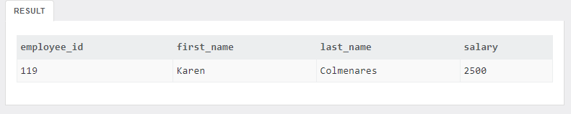

**Exercise 2**

SELECT

employee_id, first_name, last_name, salary

FROM

employees

WHERE

salary > (SELECT

AVG(salary)

FROM

employees)

ORDER BY first_name , last_name;

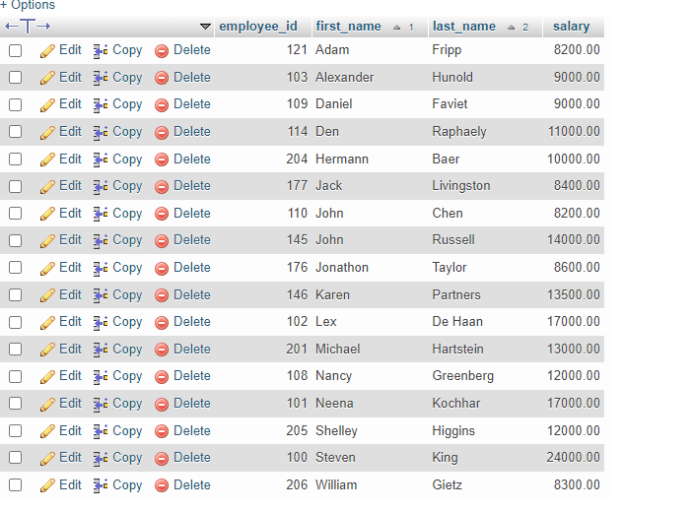

**Exercise 3**

SELECT

employee_id,

first_name,

last_name,

salary,

department_id

FROM

employees e

WHERE

salary < (SELECT

AVG(salary)

FROM

employees)

AND

department_id IN (6)

ORDER BY

department_id ,

first_name ,

last_name;

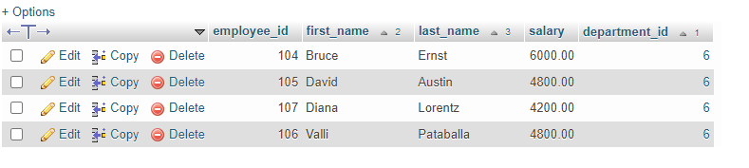

OR

SELECT

employee_id,

first_name,

last_name,

salary,

department_id

FROM

employees e

WHERE

salary < (SELECT

AVG(salary)

FROM

employees

WHERE

department_id IN (6))

ORDER BY

department_id ,

first_name ,

last_name;

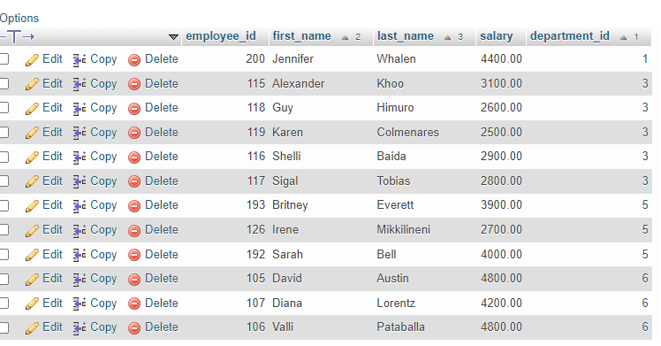

Exercise 4

SELECT

employee_id, first_name, last_name

FROM

employees

WHERE

department_id IN (SELECT

department_id

FROM

departments

WHERE

department_name = 'IT')

ORDER BY first_name , last_name;

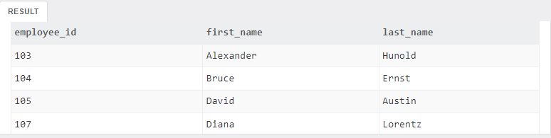

Total number of records: 5

**Exercise 5**

SELECT

employee_id, first_name, last_name

FROM

employees

WHERE

employee_id = (SELECT employee_id

FROM dependents

WHERE

first_name || ' ' || last_name = 'Jennifer King');

